**Project Documentation**

**Store Manager : Keep track of inventory**

❖ **Team ID:NM2025TMID31582**  **Team Leader:**

➢ NAME: MUTHUMATHI S

MAIL ID: [rajiis2875@gmail.co](mailto:rajiis2875@gmail.co)m

❖ **Team Members**

* NAME: PRADEEPA M

MAIL ID: pradeepaambika30607@gmail.com

* NAME: THASLIMABEGAM IA

MAIL ID: thaslimabegam2007@gmail.com

* NAME: KAYALVIZHI M

MAIL ID: kayalvizhi7102000@gmail.com

1. **Introduction : A store manager availability for customers, prevent stockout and overstocking, reduce costs , improve cash flow and maintain quality standards .**

2. Project Overview

❖ **Purpose:** Efficient inventory tracking streamlines supply chain operations ,minimising shortages, overstocking and inefficiencies.

❖ **Features:**

* To maintain optimal stock levels.
* Including real time tracking.
* Automated reordering.
* Demand forecasting.

**3. Architecture**

* Frontend: React.js with Bootstrap and Material UI

# 4. Setup Instructions

❖ **Prerequisites:**

* Node.js
* Git
* React.js
* Express.js – Visual Studio Code  **Installation Steps:**

# Clone the repository git clone # Install client dependencies cd client npm install

# Install server dependencies cd

../server npm install

# 5. Folder Structure

SB-Works/

|-- client/ # React frontend

|__components/

L__ pages/

# |__ server/ # Node.js 6. Running the Application

❖ **Frontend:**

* cd client
* npm start

❖ **Access: Visit** [**http://localhost:3000**](http://localhost:3000/)

# 7. API Documentation

❖ **User:**

* /api/user/register • /api/user/login  **Projects:**
* /api/projects/create
* /api/projects/:id • Applications: /api/apply

❖ **Chats:**

* /api/chat/send
* /api/chat/:userId

# 8. Authentication

* **JWT-based authentication for secure login**
* **Middleware protects private routes**

# 9. User Interface

* Landing Page
* Freelancer Dashboard
* Admin Panel
* Project Details Page

# 10. Testing

* Manual testing during milestones
* Tools: Postman, Chrome Dev Tools

# 11. Screenshots

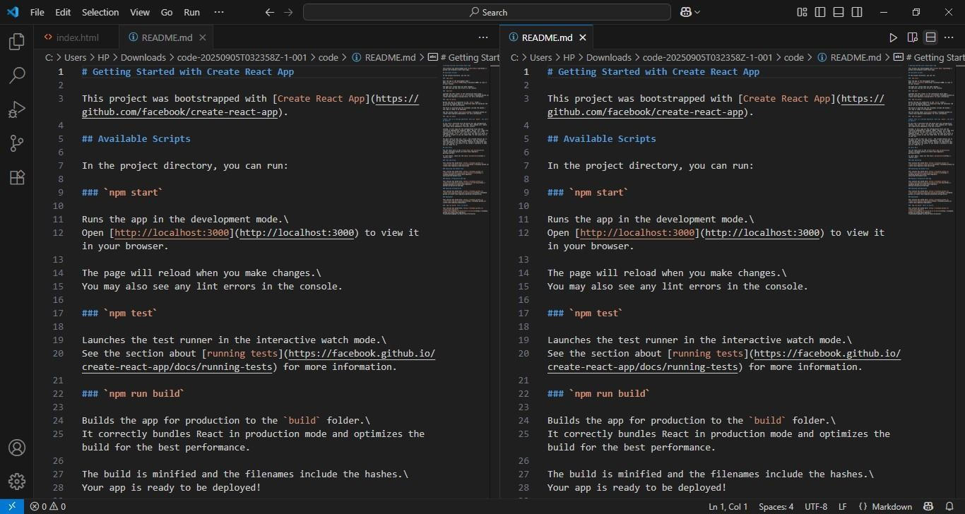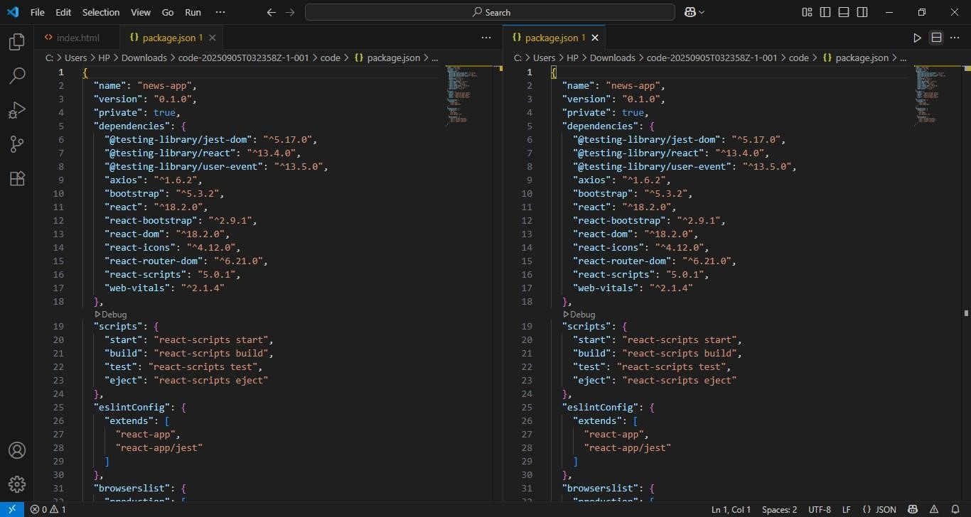

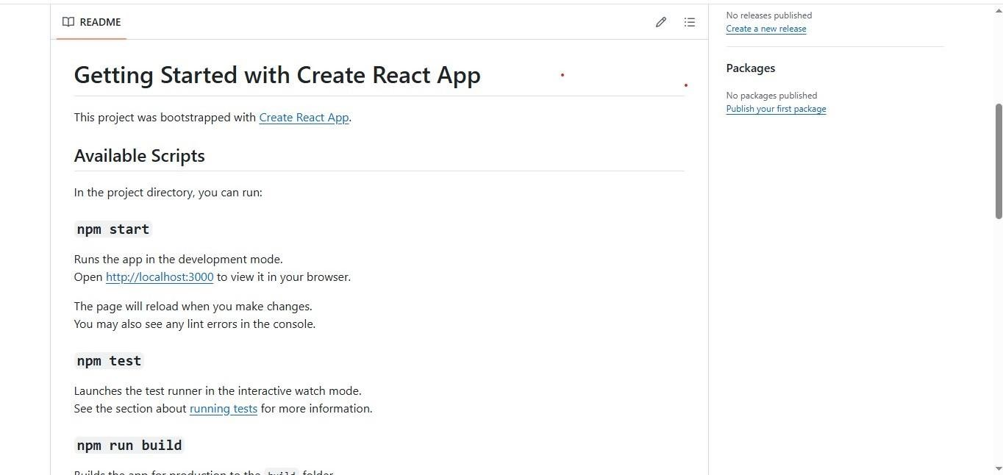

1. Known **Issues**
   * API Rate Limits
   * Server Problem
   * Navigation Glitches
2. Future Enhancements
   * Analytics Dashboard
   * Search Functionality
   * User Authentication